What is JDBC – (Introduction)  
  
JDBC stands for Java Database connectivity’s. It is a software layer that allows developers to write real client-server projects in Java. JDBC was designed to be a very compact, simple interface focusing on the execution of raw SQL statements and retrieving the results. The components of JDBC are Application, Driver manager and Driver.

It is the standards of connecting the code to multiple databases.

In this project, we are making a simple program that can connect the Java EE JDBC program with MySQL. We insert the student’s data (Name, Matric.No, Faculty) in the MySQL’s database and print that information in the Java EE program.  
  
1. A database called assignment1 contains basic info of student

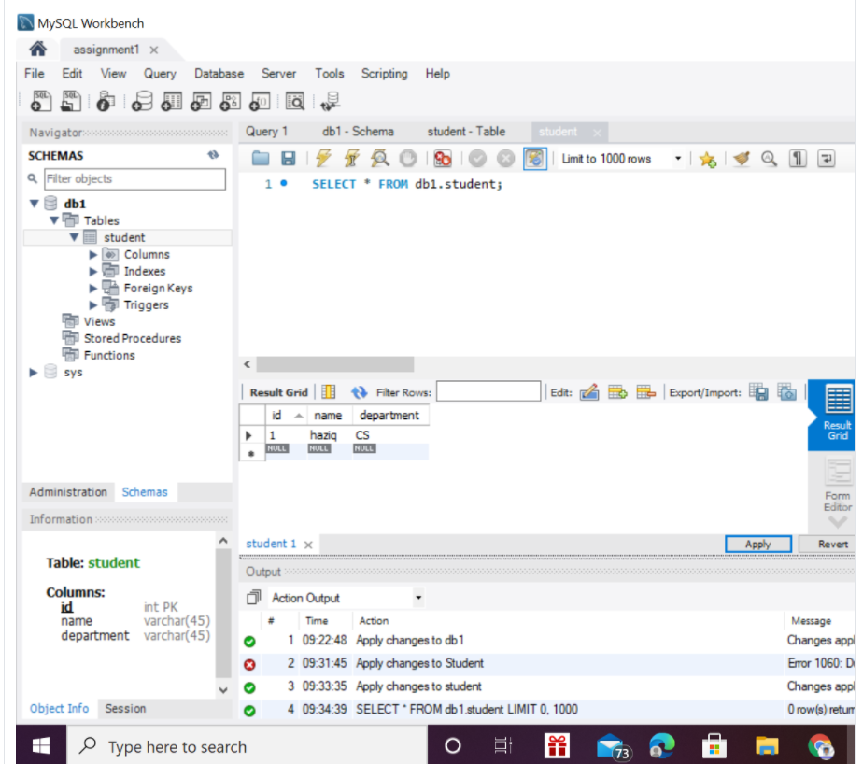

2. This code is for retrieving data that was on the MySQL database   
  
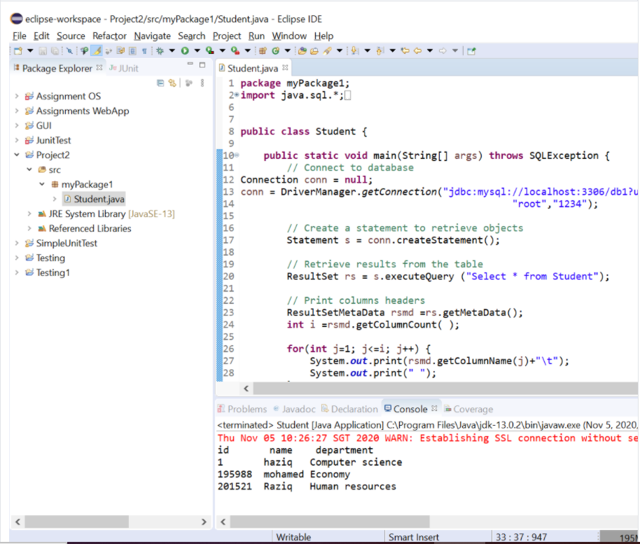

The output shows the results that was in the SQL.